Join Meeting Instructions – General Public

Until further notice, City Council, Planning Commission, and other required public meetings will be held remotely. This includes any required public hearings. Below are instructions for how to join the meeting and participate.

Note – Millersburg’s virtual meeting software is through AspenUC. This software looks and acts very much like Zoom, so may be familiar to those who have used Zoom. However, this meeting will run through a different software platform and you will need to join through AspenUC per the instructions below in order to participate in the meeting.
To join the meeting via computer:
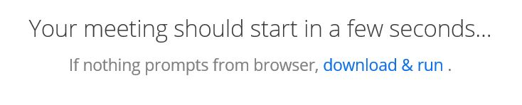
- Click on the link provided or enter the link in your web browser. You will see the following:

If this is your first time joining an AspenUC meeting, you will be prompted to install a file. This should run automatically. If not, you may need to click on the blue text. The computer will ask if you want to install the program. Click Yes.
- The program will now ask you if you want to join the audio using your computer or your phone.
  - If you want to use the computer audio and microphone, click yes. You will now join the meeting.
  - If you want to use your phone:
    - click the button on the computer screen that says ‘use phone audio.’
    - You will now join the meeting.
    - Dial 503-212-9900. When asked, enter the Meeting ID.
    - You will also be asked to enter you participant ID number. It should be on the computer screen in front you. If you do not have a participant code, just enter #.

During the meeting, all public participants will initially be muted. During periods for public comment, public participants will be unmuted.

- While the meeting is in progress, you will see the participant toolbar at the bottom of the screen.

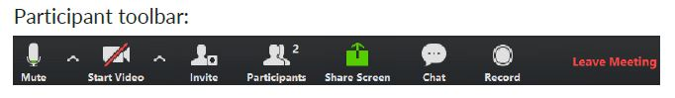
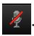
- Use the Microphone icon to toggle your microphone on and off .

- Use the Start Video icon to toggle your camera on and off (if you have a camera).

To join the meeting via phone (audio only):
- Enter the Dial-in number and when prompted, enter the Meeting ID. If you do not have a participant code, just enter #. You will be muted upon entry to the meeting.

Public Comment Periods:
During the meeting, all public participants will initially be muted. During periods for public comment, public participants will be unmuted.

- Public comment will first be taken from those who are participating via computer.
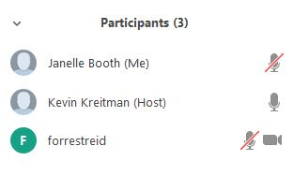
To speak during Public Comment periods “raise hand” by clicking on the “participants” icon on the toolbar. This will open the “participants” window on the right side of your screen.

All participants muted by host.

Click on the “raise hand” icon in the lower right of your screen.

This is what it looks like when your hand is raised.
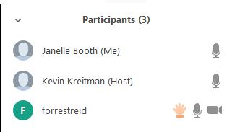

When the presiding officer calls upon you to speak, the meeting organizer will unmute you. Once your comment period is finished, you will be muted again. Public comments will be taken in the order in which the hands are raised.

- Next, public comments will be taken from those joining via phone.

The presiding officer will direct the meeting host to unmute phones and will ask those wishing to speak to state their name and city of residence. Your name will be recorded. Once your name has been recorded, please mute your phone. Once all names have been recorded, individuals will be called upon to unmute themselves and speak in the order their names were recorded.

- At the close of public comment periods, all public participants will again be muted.

All required Oregon Public Meeting laws will be strictly adhered to. These meetings will be audio/video recorded and posted to the City’s website.

