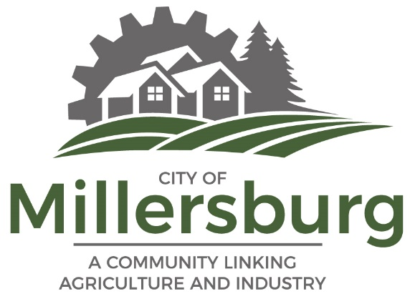

Contact: Jennifer C. Paul FOR IMMEDIATE RELEASE

Phone: 503-399-1070

Email: jpaul@sglaw.com

Website: https://www.cityofmillersburg.org/

Ruling—Linn County Circuit Court Case;
The City of Millersburg v. Pecyna et al

On October 2, 2023, in the case of City of Millersburg v. Pecyna et al, Linn County Circuit Court Judge Wynhausen, ruled in favor of the Defendant property owners. The Judge decided that the City has a valid access and utility easement; however, the grant of dedication for a conditional right-of-way interest, to the City by the former property developer, was invalid. The Court based its ruling on the West Park 2 Subdivision Plat, which was recorded on October 16, 2013, prior in time to the Defendants purchasing their interest in the subject properties.

The language in the subject plat states the following: “A 30’ WIDE ACCESS AND UTILITY EASMENT ALONG THE SOUTHERLY 30.00 FEET OF LOTS 49-54 OF THIS PLAT GRANTED TO THE CITY OF MILLERSBURG. SAID EASEMENT SHALL BE DEDICATED AS PUBLIC RIGHT-OF-WAY UPON THE REQUEST OF THE CITY OF MILLERSBURG. NO PERMANENT BUILDINGS MAY BE CONSTRUCTED WITHIN THE EASEMENT WITHOUT PRIOR AUTHORIZATION FROM THE CITY OF MILLERSBURG. BUILDING SET BACKS MUST BE APPROVED BY THE CITY OF MILLERSBURG PRIOR TO CONSTRUCTION.”

The Court concluded that while the above language was clear and unequivocal with respect to establishing an access and utility easement in favor of the City and prohibiting the Defendants from constructing any improvements within the subject area without City approval, it was not clear with respect to establishing a public right-of-way.

The City brought the present action to have the Court interpret the plat language, as part of its due diligence, and in response to a development application related to lots just south of the subject properties. The City sought to enforce its prior-in-time recorded interest in a public right-of-way upon demand, related to the extension of Zuhlke Lane, and based on a record notice theory. Ultimately, the Court concluded that the plat did not support this right-of-way interest.

The City of Millersburg Comprehensive Plan and the Millersburg Transportation Plan both incorporate the Zuhlke Lane extension. In 2007, after the City of Millersburg Planning Commission approved the West Park Development, the developer sought approval for a deed restriction on the subject lots requiring future owners to pay their share toward street development costs related to the extension of Zuhlke Lane. The City Council ultimately denied the developer’s request. The City did not want the property owners to shoulder the costs of the road expansion. Later in 2013, the developer proposed its “West Park Subdivision Tentative Plan & Variance Request.” The developer suggested the language establishing an access and utility easement with a convertible right-of-way, which the City accepted and recorded as reflected in the subject plat. The goal was to ensure access for Zuhlke Lane in the future via a convertible right-of-way interest. At that time, the City placed an additional requirement on the developer to pay the City a street frontage fee for future development of Zuhlke Lane, rather than placing that burden on the property owners.

The extension of Zuhlke Lane was identified and planned by the City at the present location before the City received the original West Park Subdivision Plan. The City intended for the Zuhlke Lane extension to provide access for the West Park Development, the future development of property owned to the south and other vacant property with development potential. Acquisition of a public right-of-way for the future extension of Zuhlke Lane will remain a condition for development in this area.

